Supporting Your Child Through Junior Cycle

A talk for parents
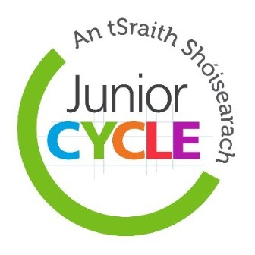

Navigating the New Junior Cycle has been a complex undertaking for schools across the country. For parents too, it has been a challenge. There are new assessment practices, new certification and changed classroom practices. Many parents are anxious about their child’s progress through Junior Cycle and their transition on to Leaving Certificate. This ‘Supporting your child through Junior Cycle’ presentation empowers parents and reinforces the teaching and learning strategies in place in your school.
- What is included:
- Rationale for change
- Benefits of the Junior Cycle for students
- New assessment procedures
- Junior Cycle Profile of Achievement
- Classroom Based Assessment
- Assessment Task
- Wellbeing in the new Junior Cycle
- Supporting your child at home. Tips, Strategies and a resource pack.
Date: Thursday 29th November 2018
Time: 7.00 to 9.00 p.m.
Facilitator: Gráinne Mulcahy – Junior Cycle Co-ordinator
Venue: Co. Wexford Education Centre, Milehouse Road, Enniscorthy.
Max enrolment: 70
To book a place please ask parents to email info@ecwexford.ie inserting “Supporting your child through Junior Cycle” in subject line.

