Wexford CBS 2- 2 Presentation College, Bray
Wexford win 4-3 on penalties

Wexford CBS were crowned champions of the Wicklow/Wexford FAI Schools league last week after an exciting finale in Arklow. In a pulsating game of excellent quality CBS took the honours after a thrilling penalty shoot-out.
Pres Bray took the initiative early on as they played a high tempo game looking to put the CBS under pressure with a direct approach. CBS weathered the early storm and soon found their tempo. The Bokerboys retained possession well and Jamie Thomas and Luke O’Neill on the wings began to exploit their opponents defence, the wingers ran at their opponents with confidence causing havoc Luke O’Neill beat two players on the right hand side before being taken down after 15 minutes. Jamie Thomas whipped in a dangerous free which Ryan Busher met at the back post but saw his effort rebound off the post, thankfully the ball landed at the feet of Sam O’Neill who tapped home to give the CBS the lead. Within 5 minutes Pres Bray had equalised, following a free kick on the half way line which they put straight into the box a defensive mux up left their number 10 unmarked and he took full advantage heading home to level the scores. In a frenetic period in the half the CBS took the lead again 5 minutes later, Dion Murphy broke with the ball from right back surging forward before playing a neat one two with striker Ryan Busher who laid a delightful pass into his path and from 20 yards Murphy hit a ferocious volley to the net leaving the keeper with no chance. 2-1 to the CBS. For the remainder of the first half the CBS continued to enjoy the better of proceedings with the midfield trio of Sam O’Neill, Paddy O’Reilly and Shane Hall dictating the play, the CBS perhaps should have used their advantage to add another and came close to doubling their advantage with Luke O’Neill firing one just over the bar on the stroke of half time.
The second half saw a resumption of a top quality affair with both teams playing superb football. Ten minutes in the Bokerboys thought they had finally found their 3rd goal after another fine delivery from Jamie Thomas the Bray keeper spilled the ball into the path of Sam O’Neill who again tapped home only to see the ref rule it out for a dubious foul in the keeper. As the game wore on Pres Bray threw everything they had forward in search of an equaliser but the CBS were handling them well restricting them to long range efforts. With ten minutes remaining however one of those long range efforts was just too good to stop as the left back from Pres Bray fired home a stunning 20 yard strike to level the scores. CBS to their credit responded well with TJ Cousins forcing the keeper into an outstanding save to keep the scores level. The CBS made some effective changes Cathal Kirwan in particular swung the midfield battle Wexford’s way, and Todd Hynes added renewed energy at left back replacing the excellent Ben Butler. Hynes almost snuck a winner in stoppage time with a free kick. In extra-time the pace of the game began to take its toll, but still both sides pushed to find an equaliser. Pres Bray were becoming increasingly frustrated as the central defensive pairing of Kallum Broaders and Jack O’Leary simply wouldn’t allow an opening. Broaders was immense and started a number of dangerous counter-attacks. The tireless running and work of Jamie Thomas and Luke O’Neill continued to cause Bray a headache with O’Neill being dragged to the ground on 3 occasions in dangerous territory, the Bokerboys almost capitalised on this each time with Hynes and Thomas delivering excellent crosses. Jack O’Leary almost capitalised in the dying minutes but saw his header go narrowly wide.
The ref blew full time and the game went to the dreaded penalty shootout. Man of the occasion and team captain Adam Dempsey was immense saving 3 penalties and scoring one himself, Todd Hynes, TJ Cousins and eventually man of the match Kallume Broaders converted for the CBS to lift the trophy after a thoroughly exciting game worthy of such a final.
It has been a remarkable season so far for this team, victory in the league sees them qualify for the quarter final of the Leinster Champions league where all Leinster league winners conjugate. They are also currently in the quarter final of the Leinster cup where they will play De La Salle Dundalk on Monday 1st February having defeated Tullow C.S, Borris, and St.Kierans College Kilkenny amongst others en route. Our under 15 side will face Colaiste Cill Mhaintain in the final of the Wicklow Wexford final later this week hoping to bring even more honours to the CBS soccer department.

Wexford CBS: Wexford CBS: Adam Dempsey (Wexford Youths), Paddy O’Reilly (Wexford Albion), Kallum Broaders (North End), Jack O’Leary (Wexford Albion), Ben Butler (Wexford Albion), Shane Hall (Wexford Albion), Dion Murphy (Wexford Albion), Sam O’Neill (Wexford Albion), Luke O’Neill (Wexford Albion), Ryan Busher (Wexford Youths), Jamie Thomas (Wexford Albion), Subs: T.J Cousins (Wexford Albion) for Busher, Cathal Kirwan (Wexford Albion) for Hall, Todd Hynes (North End) for Butler, Dylan O’Regan (North End) for Murphy, also Leon Nolan-Cullen (North End), Luke Dowdall (Wexford Albion), Chris Cowman (Curracloe Utd.)

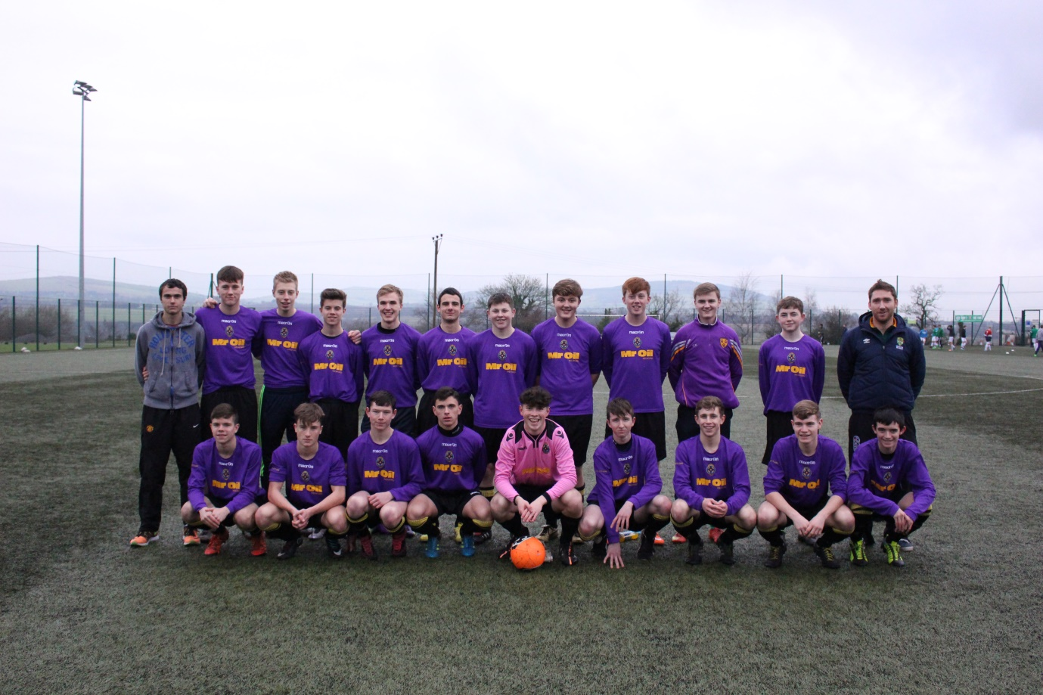
CBS Squad before match with mentors Mr. G. Forde and Mr P.Whitty
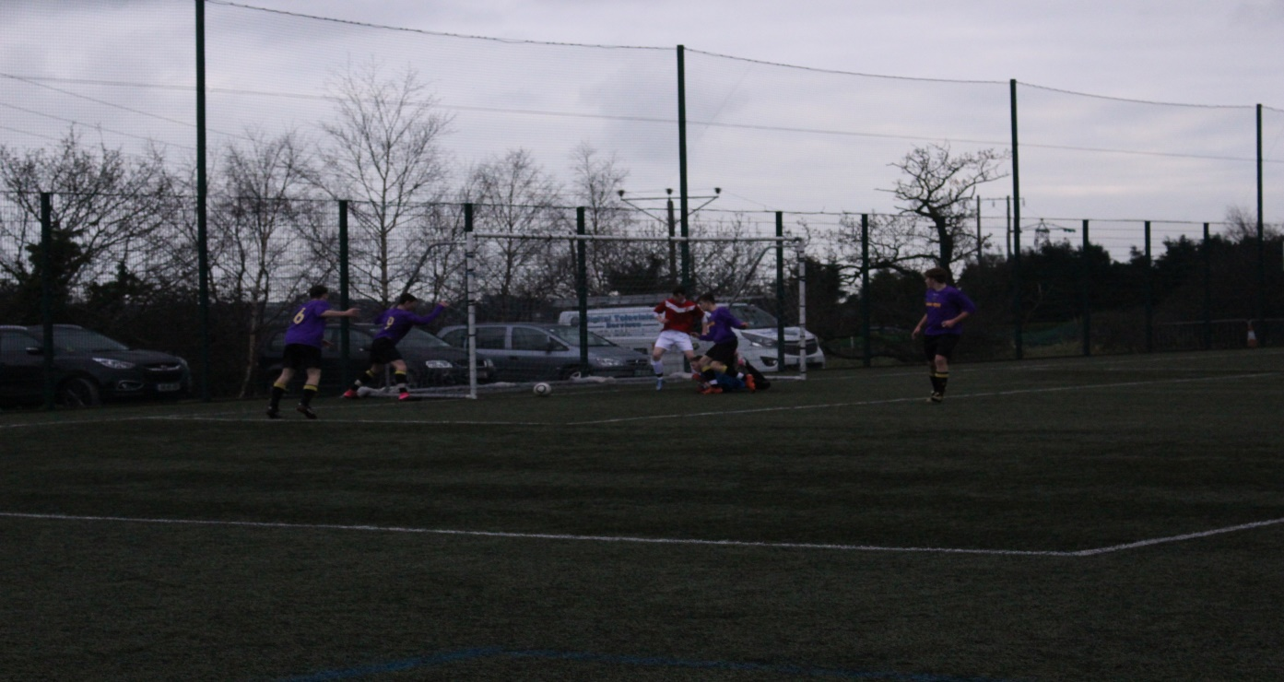
Sam O’Neill puts the CBS in front
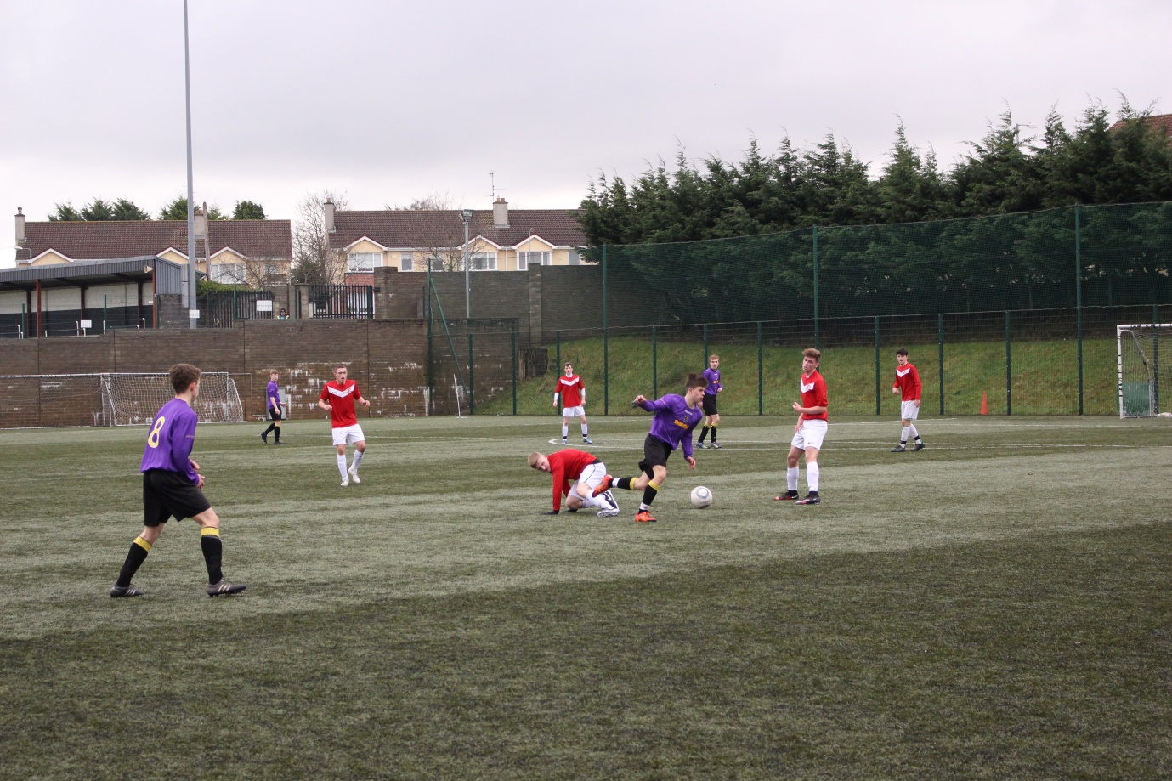
Sam O’Neill in possession

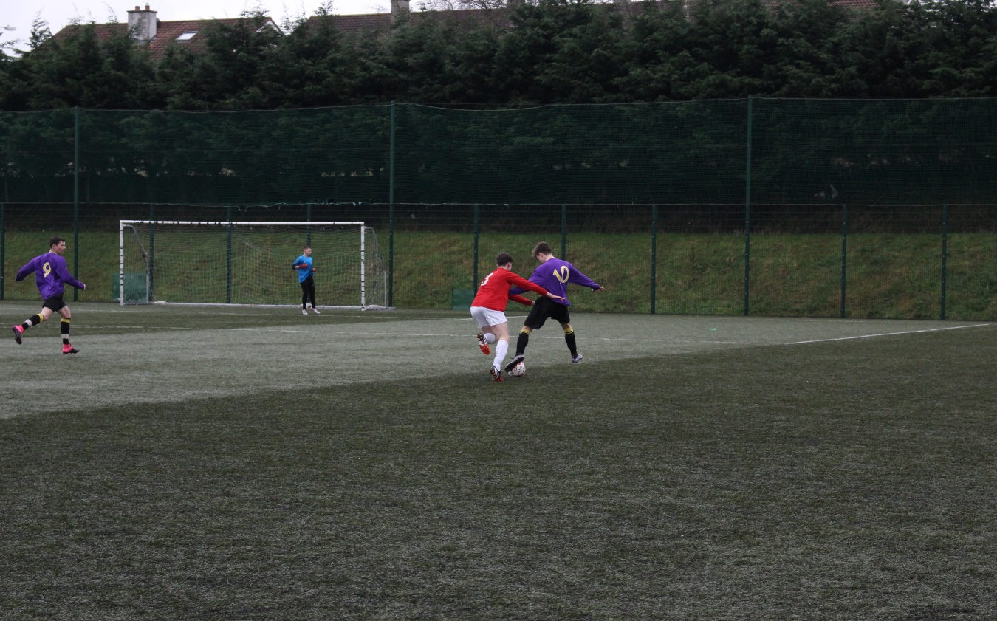
Pres Bray defence gets to grips with Luke O’Neill
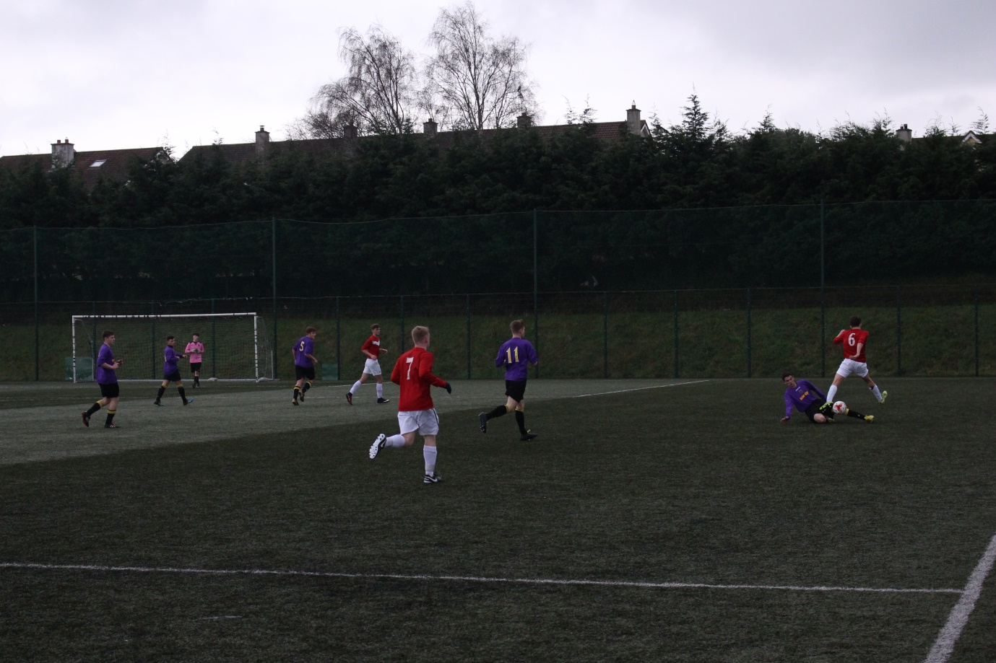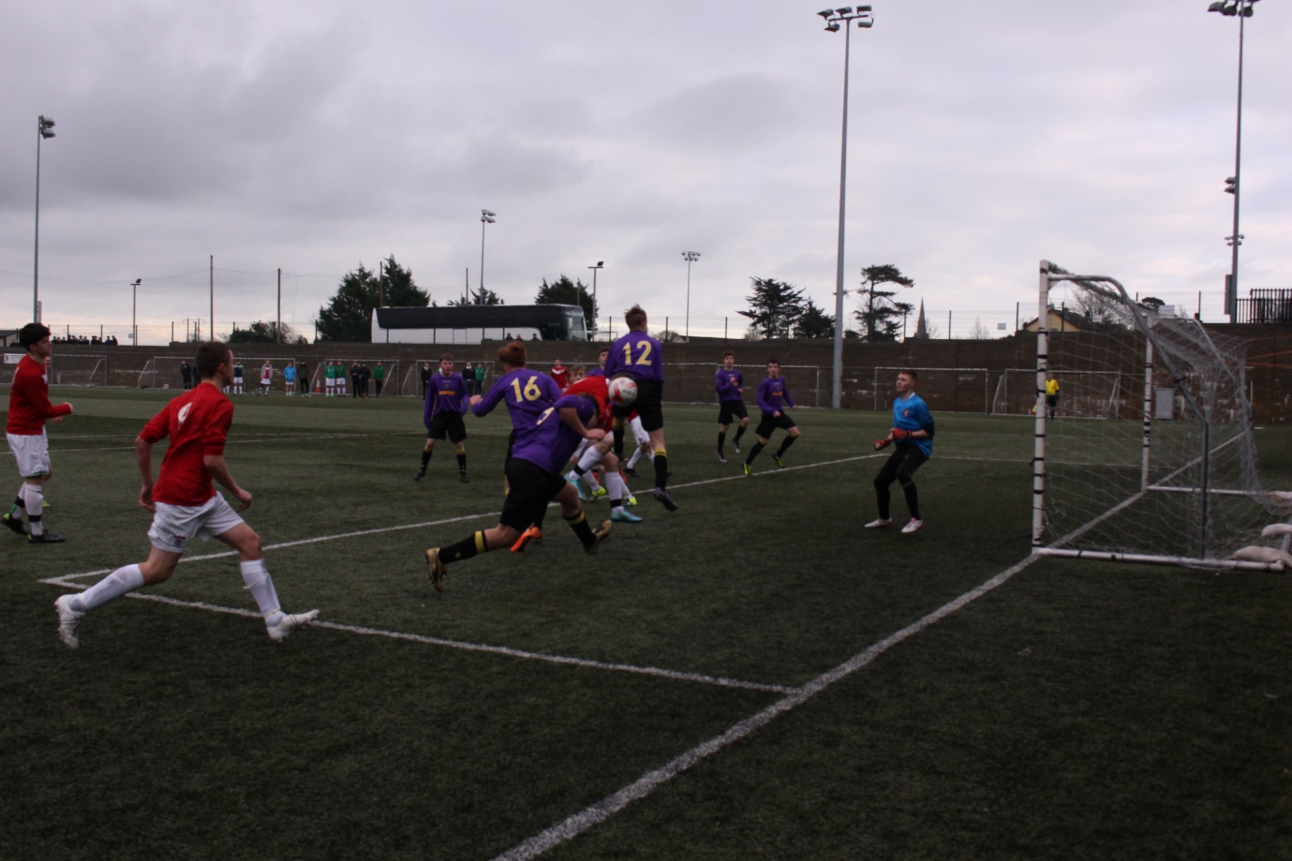
Jack O’Leary almost nets a late winner
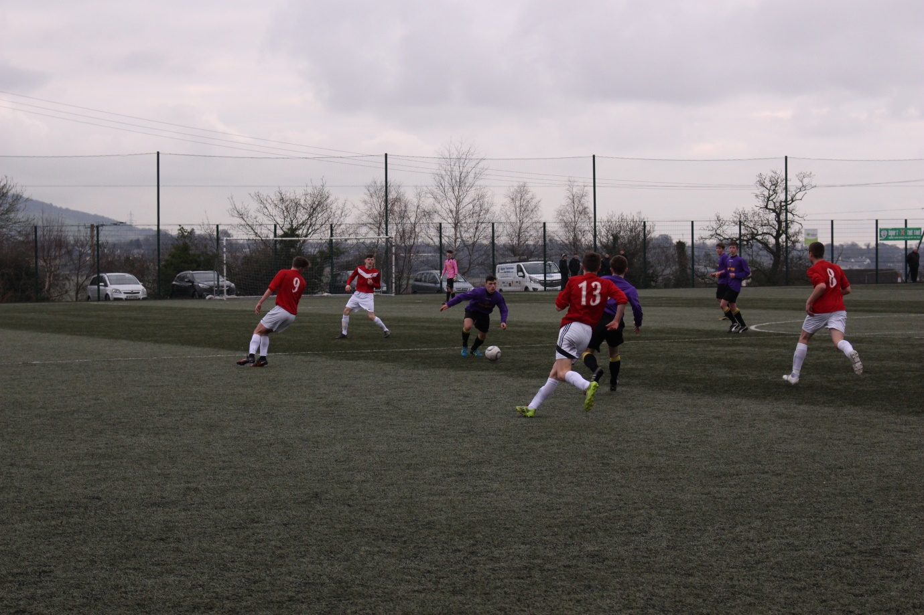
Kallum Broaders begins an attack
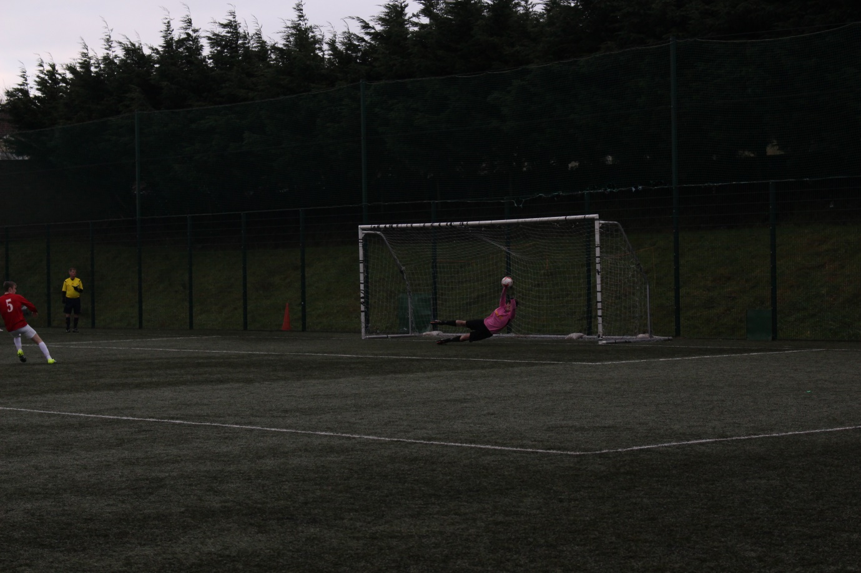
Captain Fantastic Adam Dempsey saves a 3rd penalty
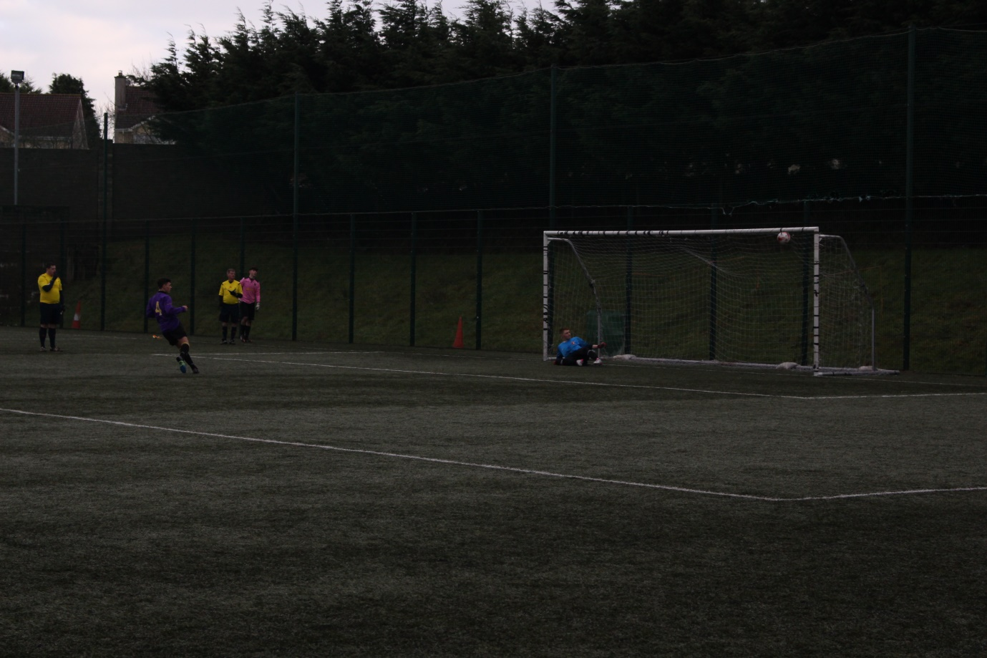
Kallum Broaders nets the winning penalty in style
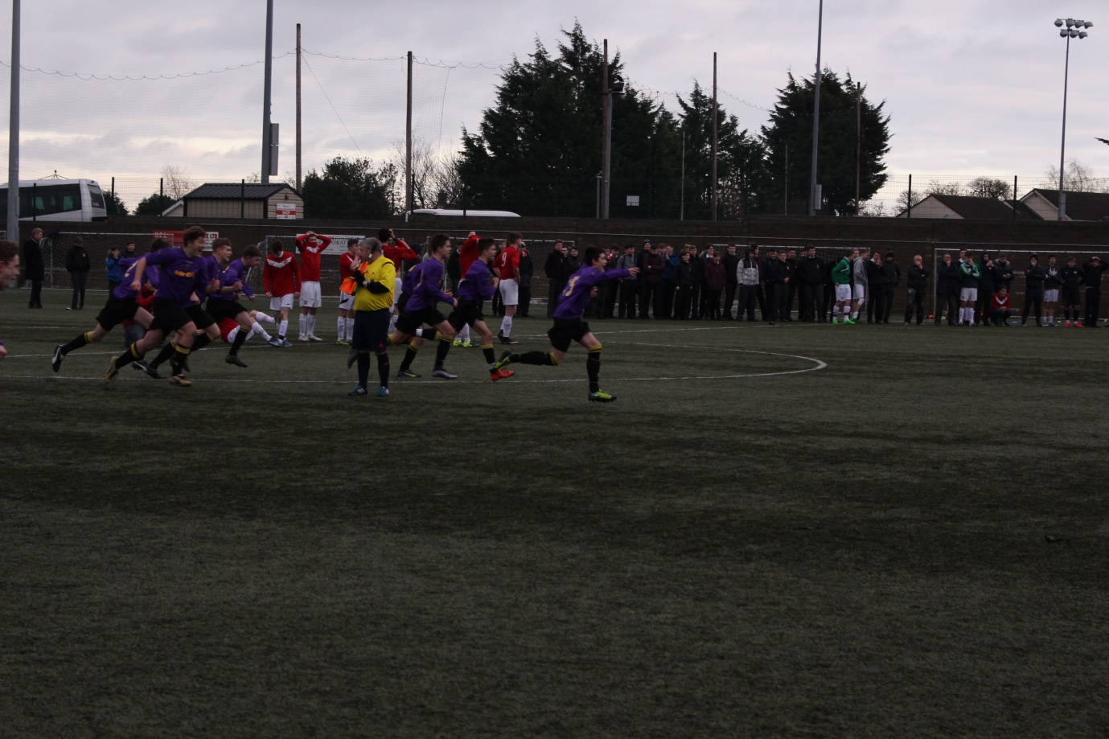
Jubilant celebrations
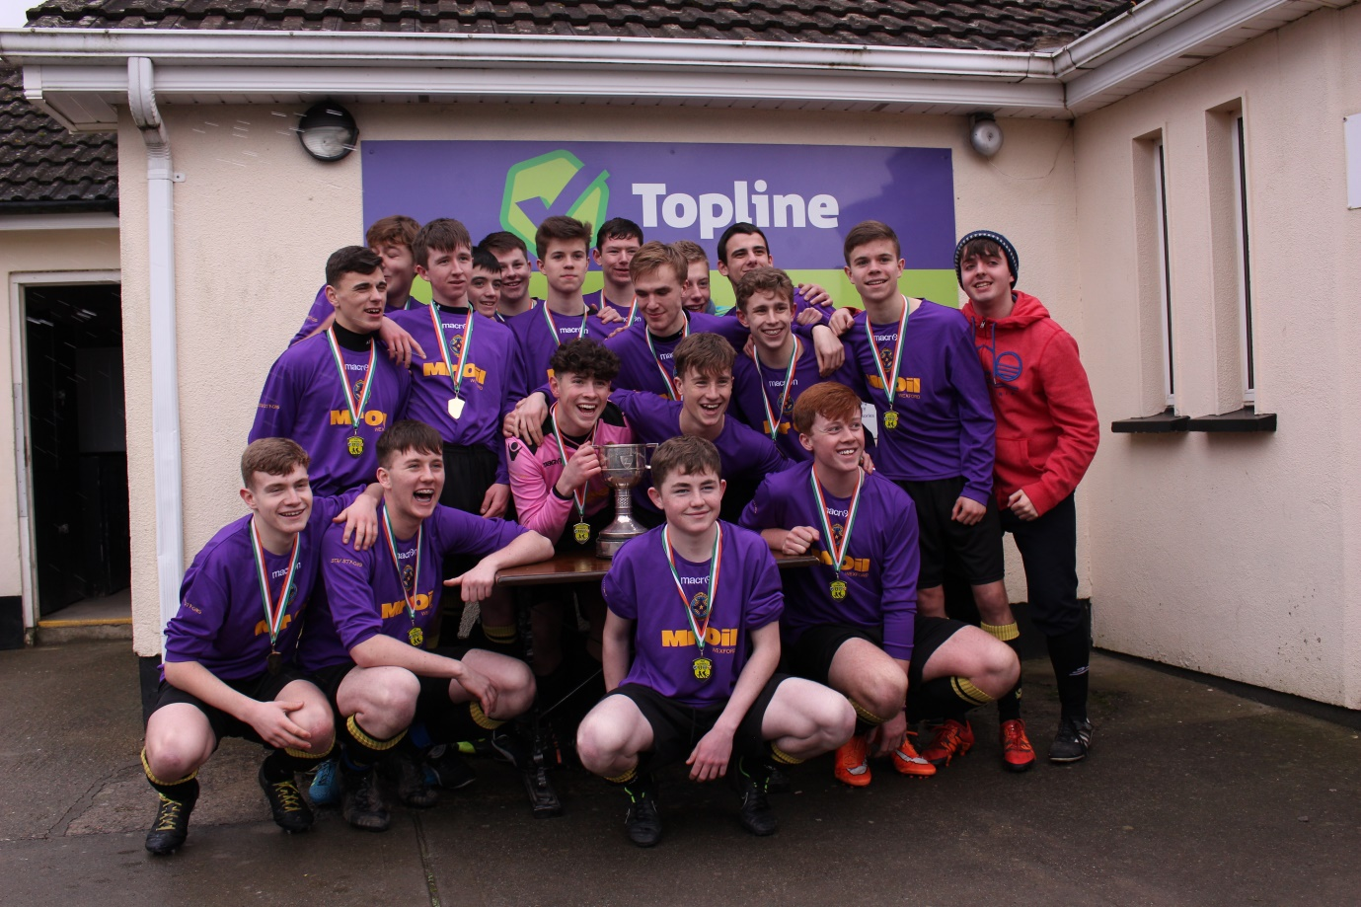
Wicklow/Wexford Champions 2015/2016

