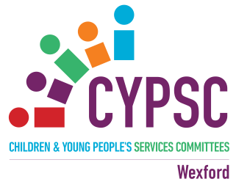

**Wexford CYPSC News and Resources Update**

**September 17th 2021**

For information on services and supports for children, young people and families see [www.wexfordcypsc.ie](http://www.wexfordcypsc.ie).

For information on supports for parents, see **Wexford Parents Hub** at [www.wexfordcypsc.ie/wexford-parents-hub](http://www.wexfordcypsc.ie/wexford-parents-hub) and on Facebook at [www.facebook.com/wexfordparentshub/](https://www.facebook.com/wexfordparentshub/).

**Contents**

**Children & Young People;**

P.3 : Wexford Great Places & Spaces Wellbeing Map for Children by Children.

P.4 : Child Talks 2021

**P. 5 : Sharing Development Concerns with Parents: A Guide for Early Childhood Professionals** : Barnardos Publication

P.6 : FDYS Updates

**Courses / Training;**

P.8 : An Cosán Courses

P.9 : An Introduction to Understanding Self Harm : Free 2 hour online facilitated zoom Training

**Parenting;**

P.10 : Understanding Anxiety and Supporting My Child : Free Online Workshop

P.11 : Parents Plus Special Needs Programme

**Mental Health;**

P.12 : MyMind is providing FREE counselling services for those affected by Covid-19

P. 13 : #HereForYou Campaign

**Funding;**

P.15 : The Community Foundation for Ireland: COVID 19 Recovery Fund

P.17 : Arts Council's Artist in the Community Scheme 2021 (Round 2)

P.18 : Covid-19 Partner Pack Update

CHILDREN / YOUNG PEOPLE

**○ Wexford Great Places & Spaces Wellbeing Map for Children by Children.**

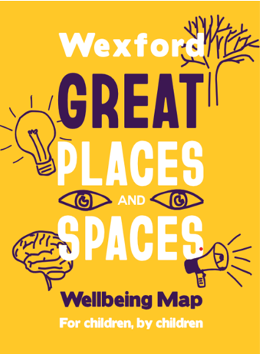

The Great Places and Spaces Project is a wonderful initiative for children, young people and families in Wexford. It is about sharing good ideas and information to inspire and encourage children, young people and families to enjoy activities and fun outside in the fresh air.

This booklet is a guide and a map for families and carers to support and encourage outdoor activities and play in the wonderful natural environments we have in County Wexford. The intention is to ensure that children and young people are active and healthy, with positive physical and mental wellbeing, in accordance with Ireland’s National Policy Framework for Children and Young People.

Being outdoors is fun. There is something about the freedom of outdoor spaces that is exciting and enjoyable.

So, check out the map and choose an outdoor adventure to enjoy today.

For more information see : <https://wexfordmentalhealthassociation.ie/great-places-and-spaces-project/>.



**○ Child Talks 2021**

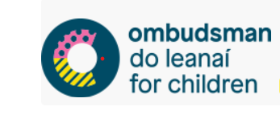

World Children’s Day takes place on 20th November and each year the OCO hosts Child Talks to mark the day.

Child Talks is an opportunity for children to tell their own stories, to share their views and to have their say. Since Child Talks began in 2018 young have people have talked about lots of different issues – school, disability, period poverty, culture, sexuality, family and lots more. It is completely up to the speakers.

The Ombudsman for Children’s Office has launched [Child Talks 2021](https://scanner.topsec.com/?r=show&d=2304&u=https%3A%2F%2Fbarnardos.us5.list-manage.com%2Ftrack%2Fclick%3Fu%3D4152bdc8473f38b88bf0eeb9a%26id%3D30491b6553%26e%3D07353ef191&t=3d672517126b2d0585127562d43a9b5ce4e426aa), an annual event where children and young people up to age 18 are given a platform to talk about the issues that matter most to them. This year’s theme is ‘My Hopes for the Future.’

See : <https://www.oco.ie/childrens-rights/child-talks> for more details.

**○ Sharing Development Concerns with Parents: A Guide for Early Childhood Professionals** : Barnardos Publication

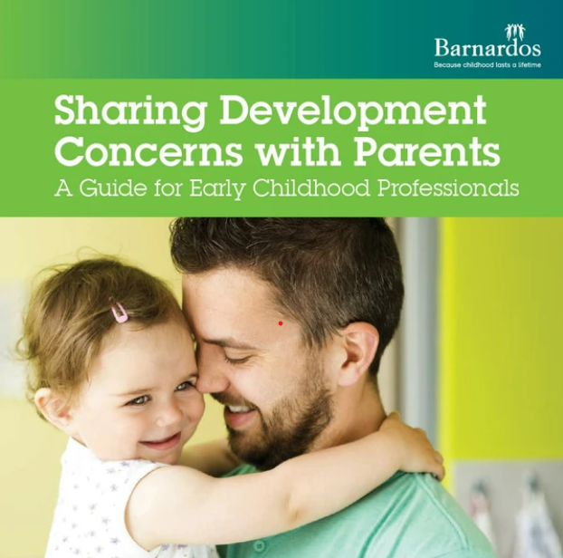

[This resource](https://scanner.topsec.com/?r=show&d=2304&u=https%3A%2F%2Fbarnardos.us5.list-manage.com%2Ftrack%2Fclick%3Fu%3D4152bdc8473f38b88bf0eeb9a%26id%3D06b3266bab%26e%3D07353ef191&t=b177e87de50f9113171c9427e4204fc227014193) offers guidance to early years professionals about how to approach difficult conversations with parents relating to concerns you have about a possible developmental delay, a sensory or learning related issue, or a behavioural or emotional issue for a child. The booklet also outlines how you can work with parents to plan steps for the family to get practical and emotional support.

For more information see : [here](https://shop.barnardos.ie/products/sharing-development-concerns-with-parents-a-guide-for-early-childhood-professionals?mc_cid=dac87d9f8b&mc_eid=d81552f666)

**○ FDYS Updates**

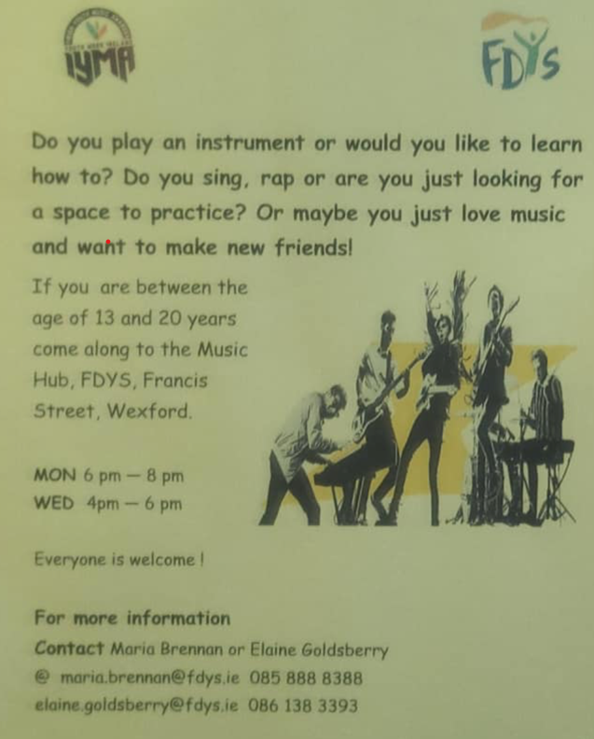

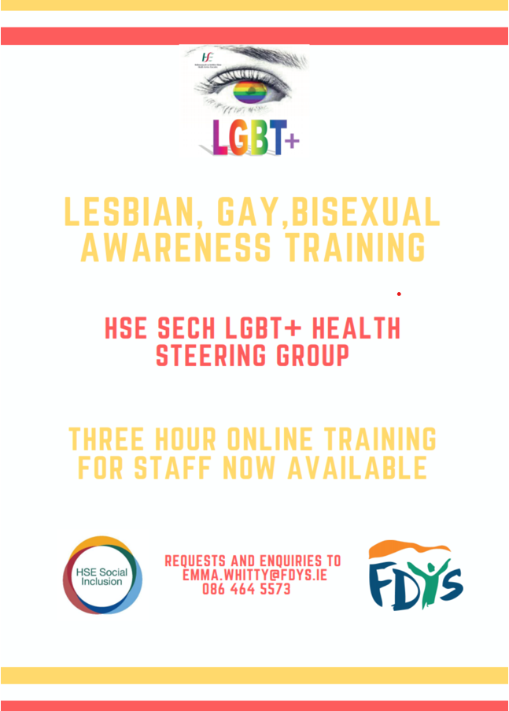

**COURSES / TRAINING**

**○ An Cosán Courses**

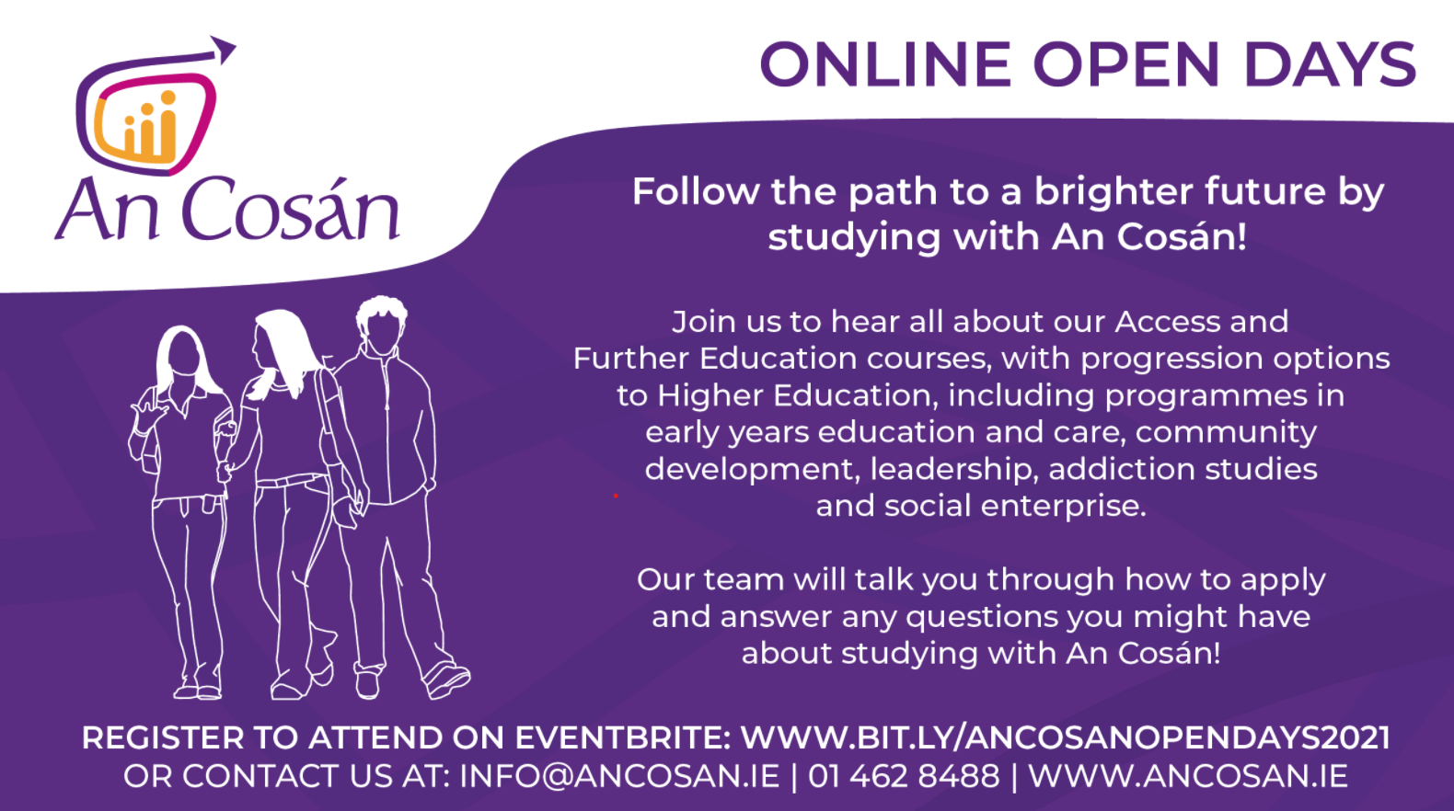

**○ An Introduction to Understanding Self Harm : Free 2 hour online facilitated zoom Training**

**This free**training is for persons over 18, especially those working in health, social care, community and educational environments. The ‘Introduction’ programme is non-clinical and aims to cover the elements of personal attitudes, various types of self-harm behaviour and the feelings and causes which may lead people to engage in the behaviour.

**At the end of the workshop, participants will:**

* Have an increased awareness of self-harm.
* Have developed an understanding of the issues faced by people who engage in self-harming behaviour.
* Develop an awareness of how to help and what additional supports are available.

This course is funded by the HSE National Office for Suicide Prevention ([**www.NOSP.ie**](http://www.nosp.ie/)). To register for An introduction to Understanding Self Harm training in the Dublin South East, Dun Laoghaire and East Wicklow region please click [**https://bookwhen.com/che**](https://bookwhen.com/che) . To register for An Introduction to Understanding Self Harm training in other regions go to [**www.nosp.ie**](http://www.nosp.ie/) and look in the local Resource Officer for Suicide Prevention information section for that region for details or contact the email address above.

HSE

**MENTAL HEALTH / ANXIETY**

○ **Understanding Anxiety and Supporting My Child : Free Online Workshop**

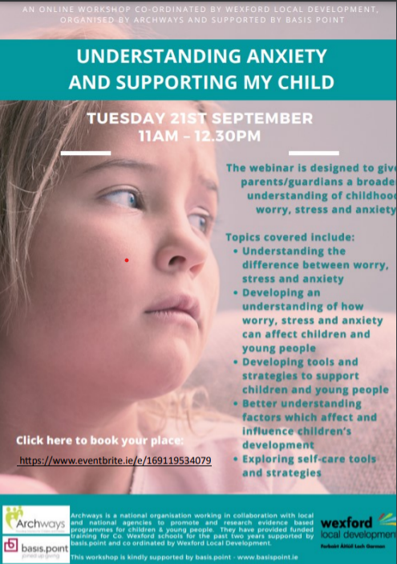

**○ Parents Plus Special Needs Programme**

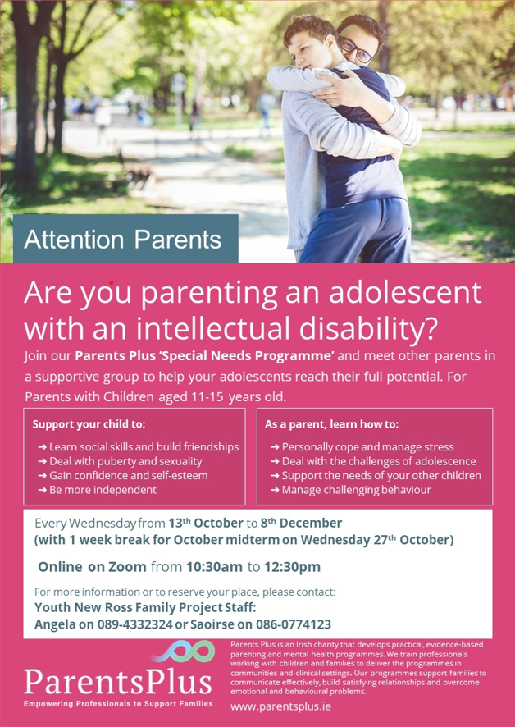

**MENTAL HEALTH**

**○ MyMind is providing FREE counselling services for those affected by Covid-19**

MyMind's free online [**#Covid**](https://www.facebook.com/hashtag/covid?__eep__=6&__cft__%5b0%5d=AZUPGQnUVhQiMIHplmc-sAS7x7j4fCSyGmD8immyqET_CfIO4gcIQaeBgtR5KMqiDuoQjguyDZPXJgRHle0lQfKNQ6MQK14WpzN5vBIwohk9XFQOpx2SzAUBhhlT8NHsieTqksQjHryFdrbiz0j3etZimVD9rB8NNdNUfc7AKF3Vv2dyzYhpzKlqky_fi64Yny4&__tn__=*NK-R)-19 sessions continue until the end of September. If you have been affected in any way by the pandemic or are feeling very stressed and overwhelmed, why not consider talking to a professional? Visit [**www.MyMind.org**](http://www.mymind.org/) for more information.

The Covid-19 Pandemic has had a ravaging effect on mental health in this country. From the fear of contracting the virus to losing our jobs or suffering isolation or bereavement, it has been a very challenging time for us all. Now, more than ever, the importance of minding our mental health is very clear.

MyMind has been at the forefront of providing much-needed mental health counselling services since 2006. Our focus has been on providing affordable and accessible mental health services within the community, bypassing the need for clinical referral, long waiting lists and high-cost services.

During the Pandemic, MyMind has already provided over 15,000 appointments through the free Covid-19 project, funded by Sláintecare and HSE Community Operations Mental Health, and this service has been extended to the end of September 2021.

As we look ahead, and in the context of the unrelenting uncertainty presented by the Covid-19 pandemic, MyMind will continue to provide high quality, accessible and affordable services. We will continue to provide discounted rates to those who are not in full employment but who are in need of mental health supports. MyMind believes that everyone who needs access to mental health supports, particularly in the context of early intervention, should get that support.

Getting help and staying connected are essential to maintaining good mental health. Talking to a qualified professional is a proven and effective way of dealing with problems of stress or anxiety.

For more information, visit our website at [**mymind.org**](http://mymind.org/), email [**hq@mymind.org**](mailto:hq@mymind.org) or call 076 680 1060.

**#HereForYouSouthEast**

This weeks campaign features Anam Cara. The assets were circulated earlier this week. Please share with your contacts and on social media where possible.

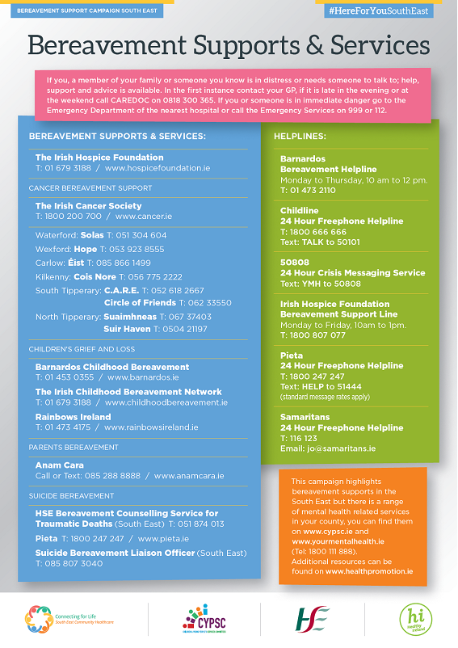

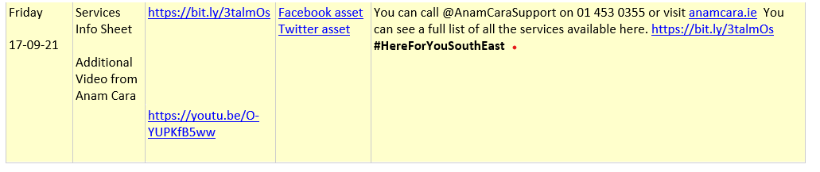

**FUNDING**

**○ The Community Foundation for Ireland: COVID 19 Recovery Fund**

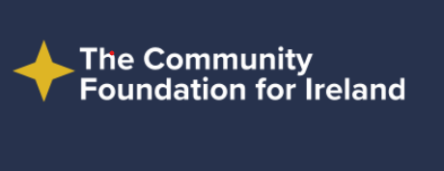

Communities and local groups are being invited to apply for grants which can help them ‘Recover Better’ as the country emerges from the Covid-19 pandemic. The Community Foundation for Ireland has re-opened its Covid-19 Recovery Fund in response to research which shows that voluntary, community and charitable groups are struggling to meet demand for lifeline supports and services.

The Community Foundation, which is providing the support from private donations, says its aim is to ensure Ireland recovers better than the pre-pandemic status quo. To achieve this ambitious goal there are two areas which have been identified as needing immediate support:

* Community Recovery and Resilience: Overcoming Isolation
* Sector Recovery and Resilience: Building Capacity

A total of €580,000 is being made available.

**Overcoming Isolation**

Isolation and the impact on health and wellbeing is affecting people of all ages. Through this funding we will support social prescribing initiatives in outdoor spaces and online. This will encourage peer support, a sense of community and improved mental wellbeing. Communities and organisations working with them have especially highlighted the need to develop outdoor opportunities for those they work with, as they grapple with living with Covid-19.

Grants of up to €3,000 will be available for grassroots and community development organisations for projects that encourage communities to overcome the isolation of the last year and a half. The key outcome of your project should be building a sense community that encourages socialising, peer support and improved wellbeing.

**Building Capacity**

In order to recover stronger from the uncertainty of the pandemic, space to think, plan and strategize is crucial. Furthermore, with the uncertainty and even greater marginalisation created by the pandemic, research and advocacy is essential for creating a more equal and resilient society. This open grant round aims to build capacity, strength and resilience within the sector to build a more equal and empowered society.

Grants of up to €20,000 are available to organisations that have been deeply affected by the pandemic.

**Applying**

Applications are now open and can be made through [**www.communityfoundation.ie**](http://www.communityfoundation.ie/)

**○ Arts Council's Artist in the Community Scheme 2021 (Round 2)**



**Artist in the Community Scheme 2021 (Round 2)  
Deadline: 5.30pm, Monday 27 September  
Web:**[**https://www.create-ireland.ie/projectsubpage/aic-awards/**](https://www.create-ireland.ie/projectsubpage/aic-awards/)

The Arts Council offers awards through the Artist in the Community Scheme to enable artists and communities of place and/or interest to work together on projects.  The Artist in the Community (AIC) Scheme is managed by [**Create**](https://www.create-ireland.ie/).

The scheme is open to artists from any of the following artform disciplines: architecture, circus, street art and spectacle, dance, film, literature (Irish and English language), music, opera, theatre, visual arts and traditional arts.

 Visit [**Artist in the Community Scheme section**](https://www.create-ireland.ie/projectsubpage/aic-awards/) for further details, including guidelines and online application form. For information on the Scheme contact [**support@create-ireland.ie**](mailto:support@create-ireland.ie) or phone 01 473 6600.

**COVID 19**

**○ Covid-19 Partner Pack Update**

Dear Colleagues,

We hope this message finds you well.

Thank you for your continuing support in helping to share information about COVID-19.

Our highlight communications updates for you from this week are:

-COVID-19 vaccine dose 2 reminder: If you had the AstraZeneca vaccine, you need a second dose to be fully vaccinated. If you do not want a second dose of AstraZeneca, you can now choose to get an mRNA vaccine dose instead. This will mean that you are fully vaccinated. Walk-in clinics are available. You can [find further information here](https://scanner.topsec.com/?d=2304&r=show&t=8c73e59f51f9f795d9b88d772a964ad18b63a103&u=https%3A%2F%2Fwww2.hse.ie%2Fscreening-and-vaccinations%2Fcovid-19-vaccine%2Fget-the-vaccine%2Fsecond-dose-mrna-vaccine-after-a-first-dose-of-astrazeneca%2F).

-Walk-in COVID-19 testing is not currently available but you can [book at test online](https://scanner.topsec.com/?d=2304&r=show&t=7e20e5a57f625b816fcd9393bdb7b3b490bb5519&u=https%3A%2F%2Fcovid19test.healthservice.ie%2Fhse-self-referral%2F) for any test centre.

-Pregnancy and getting a COVID-19 vaccine**:**it is safe to get your COVID-19 vaccine at any stage of your pregnancy. Guidance has changed on doses during pregnancy because there is more evidence available.You can [find more information here.](https://scanner.topsec.com/?d=2304&r=show&t=7d4a9566437f653d081d399363e2d5fb47eaed36&u=https%3A%2F%2Fwww2.hse.ie%2Fscreening-and-vaccinations%2Fcovid-19-vaccine%2Fget-the-vaccine%2Fpregnancy%2F)

-Many pharmacies and GPs are offering COVID-19 vaccines to people aged 12 and over. Check with your GP or pharmacy or find a participating pharmacy and [more information here](https://scanner.topsec.com/?d=2304&r=show&t=0927b6f984ca6fce4b8ead5641f53732772a4def&u=https%3A%2F%2Fwww2.hse.ie%2FApps%2FServices%2FPharmaciesServiceList.aspx).

-90% of adults have been fully vaccinated in Ireland, and approximately 84% of the population aged 12+ have been fully vaccinated.

**Public Health Measures**

You can [find information here](https://scanner.topsec.com/?d=2304&r=show&t=e330fd0b9314cb3fb5c737cf1ff7bd24f674e921&u=https%3A%2F%2Fwww.gov.ie%2Fen%2Fpress-release%2F7894b-post-cabinet-statement-resilience-and-recovery-the-path-ahead%2F%3Freferrer%3Dhttp%3A%2F%2Fwww.gov.ie%2Fen%2Fpress-release%2F0bd80-new-public-health-measures-announced-the-path-ahead%2F) about the public health measures in place.

You can find the public health measures for [September and October here.](https://scanner.topsec.com/?d=2304&r=show&t=f1d29e939a9a56f0c67d35b41482a3bec2d054a1&u=https%3A%2F%2Fwww.gov.ie%2Fen%2Fpublication%2F3361b-public-health-updates%2F)

**Mixed vaccines doses**

People who received a first dose of AstraZeneca can now receive an mRNA (Pfizer/Moderna) vaccine as their second dose. NIAC recommends that receiving two doses of the same vaccine are preferred for all age groups, where possible. You can read more about this [here](https://scanner.topsec.com/?d=2304&r=show&t=8c73e59f51f9f795d9b88d772a964ad18b63a103&u=https%3A%2F%2Fwww2.hse.ie%2Fscreening-and-vaccinations%2Fcovid-19-vaccine%2Fget-the-vaccine%2Fsecond-dose-mrna-vaccine-after-a-first-dose-of-astrazeneca%2F). Dose 2 walk-in vaccination clinics for people who wish to get an mRNA vaccine after their first dose of the AstraZeneca vaccine are listed [her](https://scanner.topsec.com/?d=2304&r=show&t=ebc9aea298bf23fceeb62ed54a1b18309b2648b9&u=https%3A%2F%2Fwww2.hse.ie%2Fscreening-and-vaccinations%2Fcovid-19-vaccine%2Fget-the-vaccine%2Ffind-a-covid-19-vaccination-centre%2F)e.

**COVID-19 Testing - Online Booking System**

Full details of [how to get tested are available here](https://scanner.topsec.com/?d=2304&r=show&t=e39174419d9025c158f8327e558a43837ebc07cb&u=https%3A%2F%2Fwww2.hse.ie%2Fconditions%2Fcovid19%2Ftesting%2Fget-tested%2F).

Walk-in testing is not currently available, but you can [book at test online](https://scanner.topsec.com/?d=2304&r=show&t=7e20e5a57f625b816fcd9393bdb7b3b490bb5519&u=https%3A%2F%2Fcovid19test.healthservice.ie%2Fhse-self-referral%2F) for any test centre.

**COVID-19 Contact Tracing - Online System**

If you get a positive test, you can use the contact tracing system to help list where you’ve been and help us to get in touch with your close contacts. You can [find more information here](https://scanner.topsec.com/?d=2304&r=show&t=95c8c36551fe1b2a20644bcd5384d9671a94d839&u=https%3A%2F%2Fwww2.hse.ie%2Fconditions%2Fcovid19%2Fcontact-tracing%2Fclose-contact%2F).

**Pregnancy and getting a COVID-19 vaccine**

You should get a COVID-19 vaccine to protect yourself from the virus if you’re:

·         pregnant

·         trying for a baby or might get pregnant in the future

·         breastfeeding

You will need 2 doses of your COVID-19 vaccine.

 It is safe to get your COVID-19 vaccine at any stage of your pregnancy.

Guidance has changed on doses during pregnancy because there is more evidence available.

You should get the COVID-19 vaccine when it is offered, following a discussion with your midwife, GP or obstetrician.

 You can [find more information here](https://scanner.topsec.com/?d=2304&r=show&t=7d4a9566437f653d081d399363e2d5fb47eaed36&u=https%3A%2F%2Fwww2.hse.ie%2Fscreening-and-vaccinations%2Fcovid-19-vaccine%2Fget-the-vaccine%2Fpregnancy%2F).

**COVID-19 Vaccination Programme**

You can find the latest information on vaccines administered [here](https://scanner.topsec.com/?d=2304&r=show&t=4253f0f16a82b8edad277e92d79d40124e7bb832&u=https%3A%2F%2Fcovid-19.geohive.ie%2Fpages%2Fvaccinations).

**12 to 15 year olds**

12 to 15 year olds can attend walk in vaccination clinics. You can [find more information here](https://scanner.topsec.com/?d=2304&r=show&t=ebc9aea298bf23fceeb62ed54a1b18309b2648b9&u=https%3A%2F%2Fwww2.hse.ie%2Fscreening-and-vaccinations%2Fcovid-19-vaccine%2Fget-the-vaccine%2Ffind-a-covid-19-vaccination-centre%2F). Children aged 12 to 15 [must attend with their parent or guardian](https://scanner.topsec.com/?d=2304&r=show&t=c28eda9d6820b7870187c52f50bf9cd7d4e6fe0e&u=https%3A%2F%2Fwww2.hse.ie%2Fscreening-and-vaccinations%2Fcovid-19-vaccine%2Fget-the-vaccine%2Fhow-to-get-a-covid-19-vaccine-for-12-to-15-year-olds%2F%23giving-consent-for-your-child).

 We're inviting parents of children aged 12 to 15 to register their children now. All children in this age group are being offered a vaccine but we particularly recommend that they get vaccinated if they:

·         have a health condition that puts them at higher risk of severe illness from COVID-19

·         live with someone who is at higher risk of COVID-19

Parents can read more about the benefits and risk of vaccination for their children [here](https://scanner.topsec.com/?d=2304&r=show&t=67694ca58f945220457d7a3f55bcced9ba88b494&u=https%3A%2F%2Fwww2.hse.ie%2Fscreening-and-vaccinations%2Fcovid-19-vaccine%2Fget-the-vaccine%2Fdeciding-on-vaccination-for-12-to-15-year-olds%2F).

[Register online to get a COVID-19 vaccine](https://scanner.topsec.com/?d=2304&r=show&t=efa2aedba5f3b9760fbf0f22edd4440949f8c466&u=https%3A%2F%2Fwww.gov.ie%2Fen%2Fservice%2Fregister-to-get-a-covid-19-vaccine%2F).

[Read the user guide for help with registering online](https://scanner.topsec.com/?d=2304&r=show&t=8ee6a6316750f8e8ae5d4716b335edd0d54df078&u=https%3A%2F%2Fwww2.hse.ie%2Fscreening-and-vaccinations%2Fcovid-19-vaccine%2Fuser-guide%2F).

[Find information here on who can give consent for vaccination](https://scanner.topsec.com/?d=2304&r=show&t=a9661a1691502d97287c744ba13750f4ee7750b0&u=https%3A%2F%2Fwww.hse.ie%2Feng%2Fhealth%2Fimmunisation%2Fhcpinfo%2Fcovid19vaccineinfo4hps%2Fwho-can-give-consent-for-young-people-aged-under-16.pdf) of a young person aged under 16 years

If you cannot register online, you can [call the COVID-19 helpline](https://scanner.topsec.com/?d=2304&r=show&t=870f2bee0f241a94c975a333fa4e50f0dcc338a4&u=https%3A%2F%2Fwww2.hse.ie%2Fservices%2Fcontact-the-hse%2F) at Freephone: 1800 700 700 to register by phone.

**Find a pharmacy giving COVID-19 vaccines**

Many pharmacies are now offering COVID-19 vaccines to people aged 12 and over. Find a pharmacy to book your vaccine appointment. You can [find more information here](https://scanner.topsec.com/?d=2304&r=show&t=0927b6f984ca6fce4b8ead5641f53732772a4def&u=https%3A%2F%2Fwww2.hse.ie%2FApps%2FServices%2FPharmaciesServiceList.aspx).

**Where to find COVID-19 Vaccination Information**

We encourage everyone to read about the COVID-19 vaccine and to get their information from a factual, trusted source – here are the links to the pages with information on the vaccine:

·         Check [https://www2.hse.ie/screening-and-vaccinations/covid-19-vaccine/](https://scanner.topsec.com/?d=2304&r=show&t=90dadee5f03269fc99594b6b11f863b1e74a1dba&u=https%3A%2F%2Fwww2.hse.ie%2Fscreening-and-vaccinations%2Fcovid-19-vaccine%2F) for information about the vaccine, information on this page is updated regularly

·         Find the vaccine information materials at[https://www.hse.ie/eng/services/covid-19-resources-and-translations/covid-19-vaccine-materials/](https://scanner.topsec.com/?d=2304&r=show&t=bd0ed22b0b9cf5ce443099423c9f70f080feda93&u=https%3A%2F%2Fwww.hse.ie%2Feng%2Fservices%2Fcovid-19-resources-and-translations%2Fcovid-19-vaccine-materials%2F)

·         Details on COVID-19 vaccines administered are available [here](https://scanner.topsec.com/?d=2304&r=show&t=cfa208253ae3409daccec630ce078370c7184850&u=https%3A%2F%2Fcovid19ireland-geohive.hub.arcgis.com%2Fpages%2Fvaccinations)

·         Read the [full COVID-19 Vaccine Allocation Strategy](https://scanner.topsec.com/?d=2304&r=show&t=2717c6423e3872cec626457f1e892c53ebc21bb0&u=https%3A%2F%2Fwww.gov.ie%2Fen%2Fpublication%2F39038-provisional-vaccine-allocation-groups%2F)

·         Read the [National Immunisation Advisory Committee Chapter about COVID-19 vaccine](https://scanner.topsec.com/?d=2304&r=show&t=77ed1c545eabdd85754416461e438aa64e44c8c5&u=https%3A%2F%2Fwww.hse.ie%2Feng%2Fhealth%2Fimmunisation%2Fhcpinfo%2Fguidelines%2Fcovid19.pdf)

·         [COVID-19 vaccine information for health professionals](https://scanner.topsec.com/?d=2304&r=show&t=e98c0eec31520824bbc52904fe190026eb7d795b&u=https%3A%2F%2Fwww.hse.ie%2Feng%2Fhealth%2Fimmunisation%2Fhcpinfo%2Fcovid19vaccineinfo4hps%2F%3Futm_source%3DBroadcast%26utm_medium%3DEmail%26utm_campaign%3DCovid%252019%26utm_content%3DUpdate%2520on%2520vaccine%2520rollout%2520-%2520Staff%2520Update)

·         Information in Irish Sign Language: information resources on the COVID-19 vaccines in Irish Sign Language are available [here](https://scanner.topsec.com/?d=2304&r=show&t=17a7e333d48ba35c59f3dd60bb28cc21aed499b6&u=https%3A%2F%2Fwww.hse.ie%2Feng%2Fservices%2Fcovid-19-resources-and-translations%2Fcovid-19-irish-sign-language-resources%2Fcovid19-vaccine-irish-sign-language-resources.html).

**COVID-19 Guidance for hospitality businesses (formerly guidance for food service businesses)**

You can find this [guidance for employers and employees here](https://scanner.topsec.com/?d=2304&r=show&t=2a6045c7dec96033b65a8c7752a71010da015207&u=https%3A%2F%2Fwww.hpsc.ie%2Fa-z%2Frespiratory%2Fcoronavirus%2Fnovelcoronavirus%2Fguidance%2Femployersemployeesguidance%2FHospitality%2520guidance.pdf).

**Guidance for places of worship (formerly religious services guidance)**

You can find this [guidance here](https://scanner.topsec.com/?d=2304&r=show&t=288f8893a0a418a21df20ab7827ef81a58c6460c&u=https%3A%2F%2Fwww.hpsc.ie%2Fa-z%2Frespiratory%2Fcoronavirus%2Fnovelcoronavirus%2Fguidance%2Fplacesofworshipguidance%2FCOVID_religious%2520settings.pdf). 

**Identify your strengths and improve your wellbeing**

HSE Health and Wellbeing is hosting the webinar, ‘Identify your strengths and improve your wellbeing’ on Thursday, 16th September from 2-3pm. Recognising your strengths will help to improve your wellbeing and manage the many stresses and challenges we face in life, both in our personal and working lives.

You can [register for the webinar here](https://scanner.topsec.com/?d=2304&r=show&t=ee5343cdcd8b6ba1623fd9224e0b76b24999476d&u=https%3A%2F%2Fims.zoom.us%2Fwebinar%2Fregister%2FWN_kRDm8JTsSJW7rluMRQEHVA).

**Public Health Information**

As always, for the most up to date information and advice on Coronavirus, please go to: [https://www2.hse.ie/conditions/covid19/](https://scanner.topsec.com/?d=2304&r=show&t=9abe83ffe08dfa945a3b5971b371833cd8d33dd1&u=https%3A%2F%2Fwww2.hse.ie%2Fconditions%2Fcovid19%2F) and [https://www.hpsc.ie/a-z/respiratory/coronavirus/novelcoronavirus/](https://scanner.topsec.com/?d=2304&r=show&t=0930e0b429bfda8a50a3c12023ffe813390e742f&u=https%3A%2F%2Fwww.hpsc.ie%2Fa-z%2Frespiratory%2Fcoronavirus%2Fnovelcoronavirus%2F). Clinical and professional guidance relating to COVID-19 is available on [www.hpsc.ie](https://scanner.topsec.com/?d=2304&r=show&t=dd668c9ecf613147289f1169b3425254728e0211&u=www.hpsc.ie) where you’ll find up to date guidance for healthcare settings and non-clinical settings.

Please check [here](https://scanner.topsec.com/?d=1824&u=https%3A%2F%2Fwww.hse.ie%2Feng%2Fservices%2Fnews%2Fnewsfeatures%2Fcovid19-updates%2Fpartner-resources%2F&t=169b469b07509acc930b8cf02a9a1011eaf65111) for the most up to date partner resources for COVID-19.

You can find the [COVID-19 A-Z information here](https://scanner.topsec.com/?d=2304&r=show&t=9d87e29abf75dc75afe90068a26a29213694e996&u=https%3A%2F%2Fwww.hpsc.ie%2Fa-z%2Frespiratory%2Fcoronavirus%2Fnovelcoronavirus%2Fcovid-19a-z%2F) from the HSE’s Health Protection Surveillance Centre (HPSC).

 Please also check the Healthy Ireland site [here](https://scanner.topsec.com/?d=2304&r=show&t=7393033dc04a181b66a6c7d97382c61deab9a4c3&u=https%3A%2F%2Fwww.gov.ie%2Fen%2Fcampaigns%2Fhealthy-ireland%2F%3Freferrer%3Dhttp%3A%2F%2Fwww.gov.ie%2Fhealthyireland%2F) with further resources and information on the Keep Well campaign.

 You can view the latest information on how Ireland is responding to cases of COVID-19 [here](https://scanner.topsec.com/?d=2304&r=show&t=a99bb71670f79403755b33358ecc4deed768892e&u=https%3A%2F%2Fwww.gov.ie%2Fen%2Fcampaigns%2Fc36c85-covid-19-coronavirus%2F).

 Ireland’s COVID-19 Data Hub is [available here](https://scanner.topsec.com/?d=2304&r=show&t=041c027e89ce2e1f4019049aaf59e4def01c210f&u=https%3A%2F%2Fcovid19ireland-geohive.hub.arcgis.com%2F).

 Many thanks and best wishes,

